**BATCH FILE EXECUTION**

**Ex No :02**

**Date :08-05-2023**

**Aim :**

To create and execute batch file in windows.

**Procedure :**

1.create a text document.

2.write the following commands.

* @echo
* echo hello
* Pause
* echo this is new
* echo this is second one
* pause

3.save file as test.bat

4.Run the bat file to get the output

**Bat File**

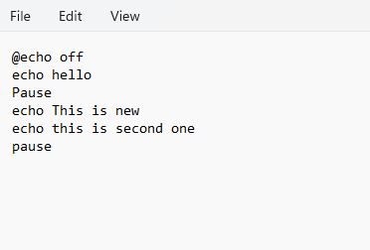

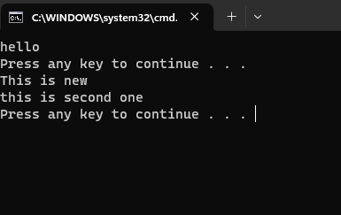**Output**

**Result :**

Hence the Batch file Windows ids executed.